Name-Adarsh Yadav
Roll No.:202401100200018
Branch:CSE-A

Submission Evidence:

- GitHub repository URL: adarsh-0045/github-skills-challenge

- Pull request URL used to validate the workflows:

Trigger pull request workflows by adarsh-0045 · Pull Request #1 · adarsh-0045/github-skills-challenge

- Screenshot showing the GitHub Actions workflows:
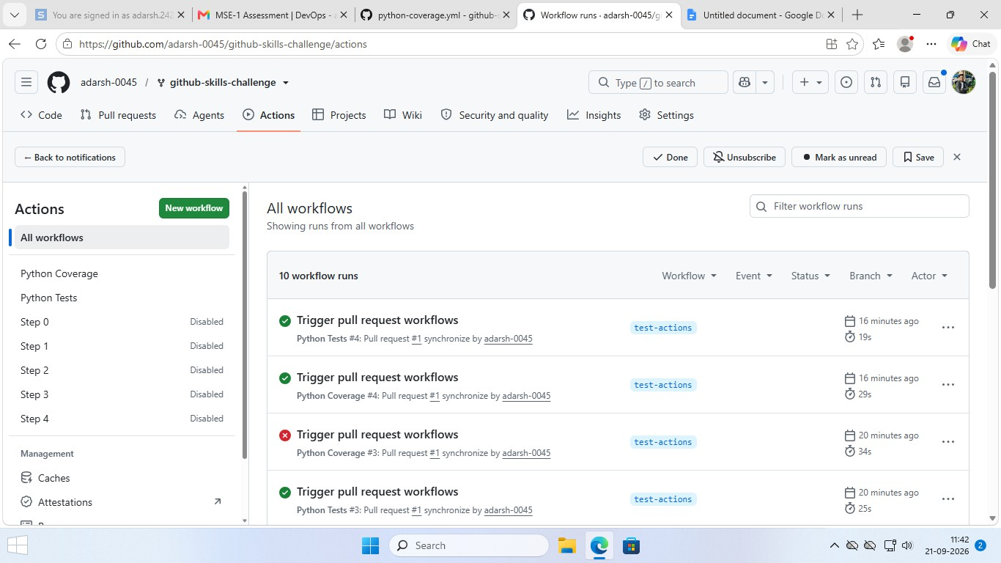

- Screenshot showing a successful test workflow execution:

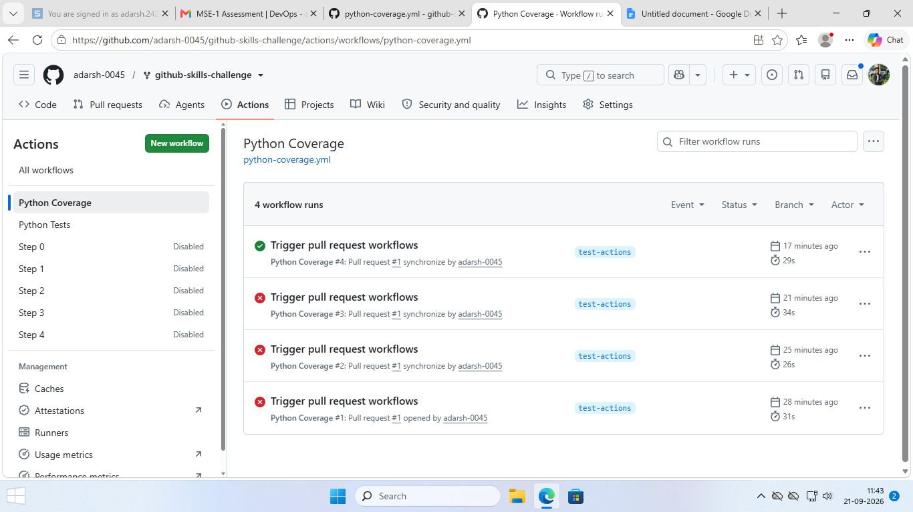
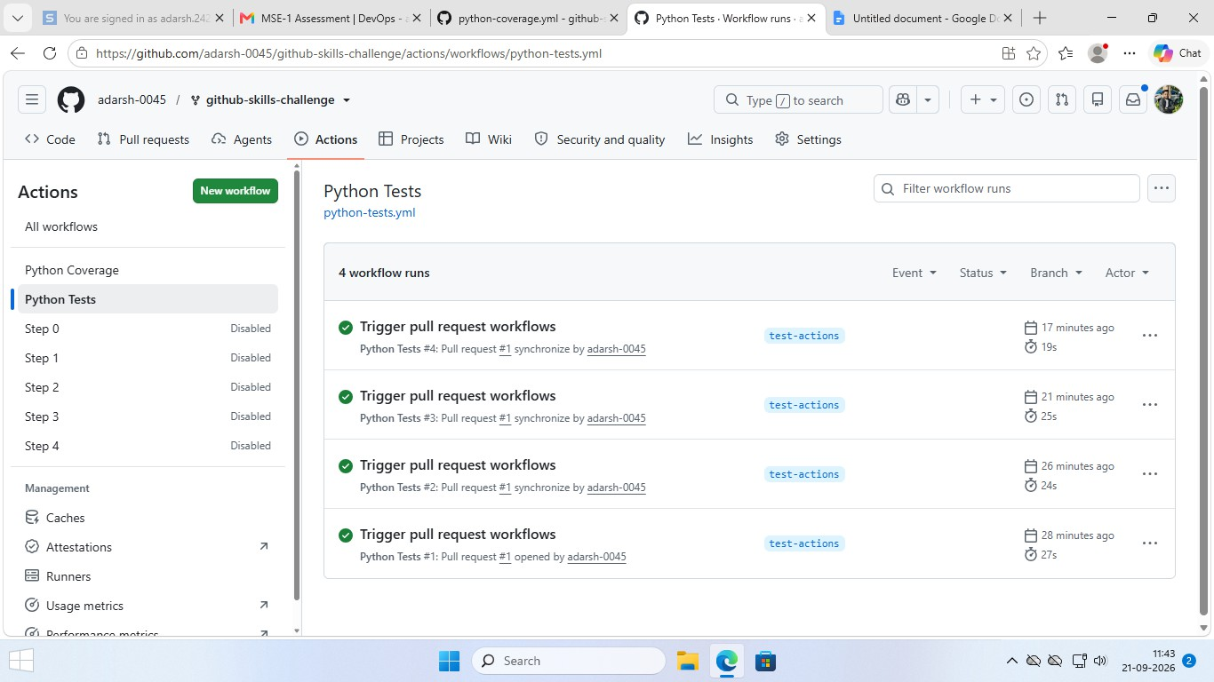

- Screenshot showing the coverage result/comment on the pull request:

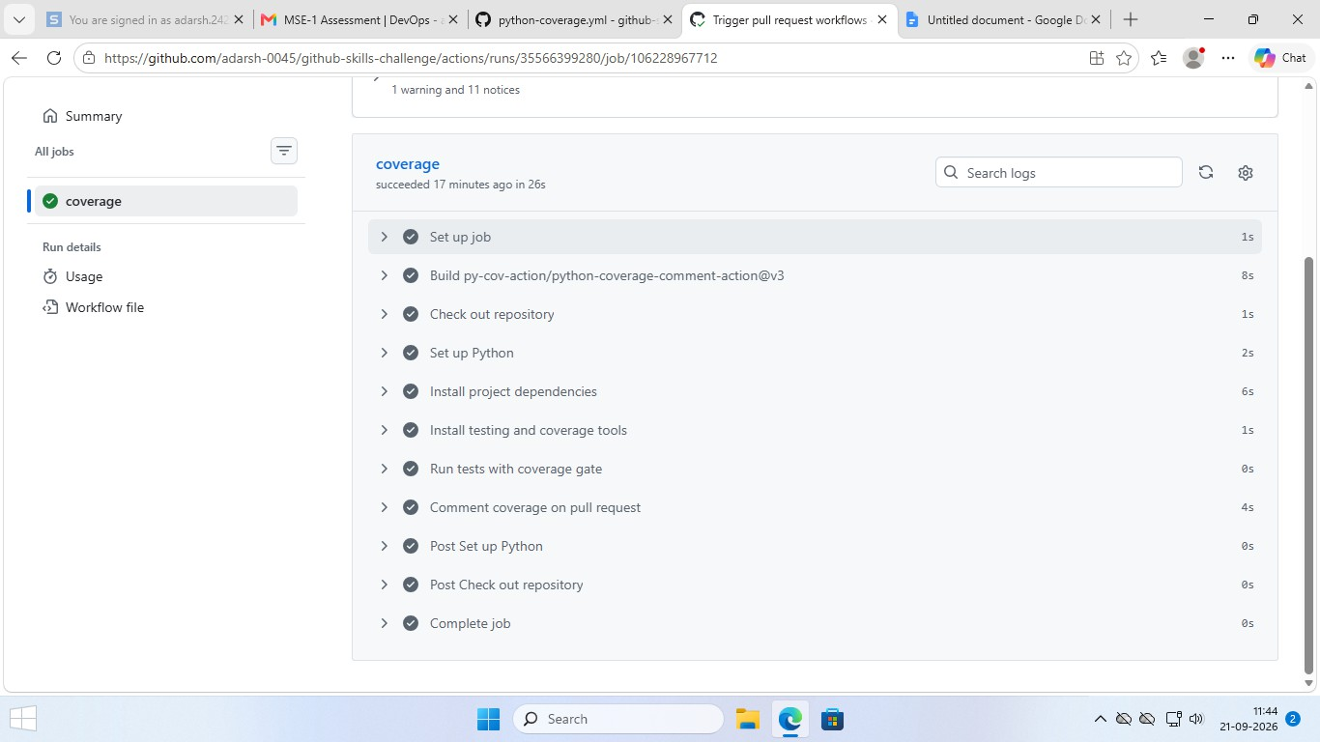

- Screenshot showing the final repository/workflow files:
